**Software Report**

Final Documentation for the Bowling Assignment:

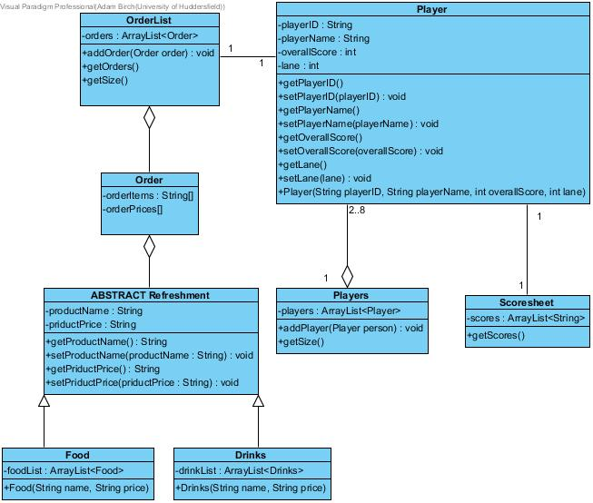

Figure

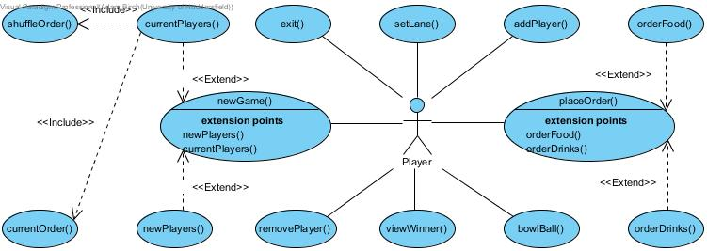

Figure

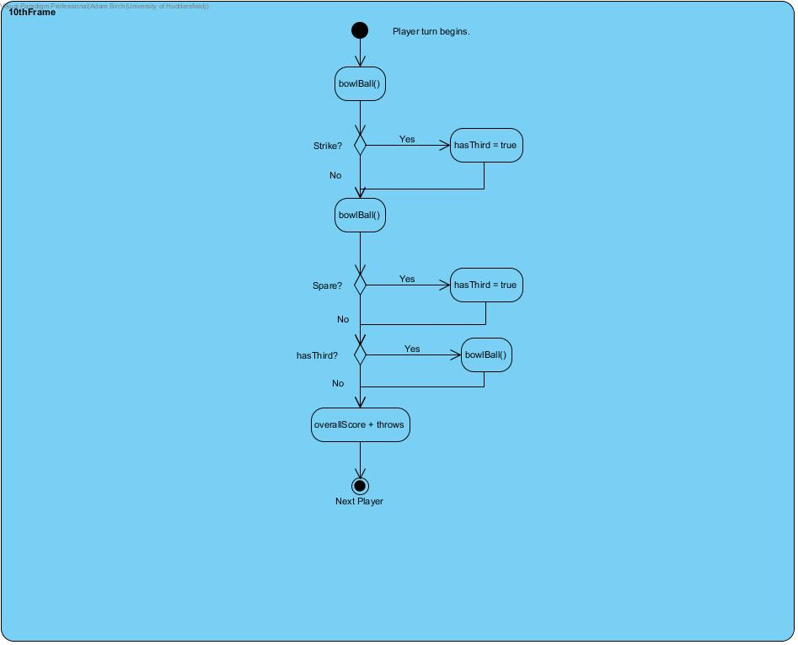

Figure

Figure 1 is the Class Diagram for all interactions between the Player class and the other classes.

Each Player object has a Scoresheet object, hence a 1 to 1 relationship. However, the Players class is made up of Player objects, and will contain between 2 and 8 objects.

Each Player object has a list of orders. This can have any number of order objects that can have any number of items within each. The values are stored for the user however nothing is done with this information as it would be sent to another system that would deal with the orders.

Food and Drinks are objects that inherit from Refreshments. As refreshments are always of type Food or Drink, Refreshments is Abstract so that no object of type Refreshment can be created.

Other than Overall Score and Lane, all numerical values are stored as String values. This is because the String operations are more useful within the program, such as Formatting and searching the last frames score for an X or / for strike and spare handling respectively.

Figure 2 shows the user interactions within the system. Most of the interactions are self-explanatory, as the user can create players, set the lane, bowl the ball, order food, etc.

I chose to omit the cancelling orders, etc, as these functions merely prevent the change from being made. Orders are cancelled before they are created and added to the user’s orders list.

The extension of currentPlayers for newGame includes either shuffleOrder or currentOrder, but not both. This allows the user to specify the run order for the next game.

Figure 3 is a basic run-through of how the 10th frame will work. This shows that a Boolean value is used to determine if the user can take a 3rd throw. I omitted the Strike and Spare handling for the last (8th and 9th) frames as they are part of the normal running, and omitted the number of pins available for each frame. Unless the player cleared the lane on the 2nd throw, the number of pins available for the 3rd throw will be the number left after the 2nd. In this scenario the maximum number of pins hit in the 10th frame is 20 – a Strike followed by a Spare.

The following table is the Test plan and results of the created software. Some screenshots are too large to view in the table. Such screenshots appear below the table but are referenced within.

|  |  |  |  |  |  |  |
| --- | --- | --- | --- | --- | --- | --- |
| ID | Type | Data | Expected result | Actual result | Screenshot | Pass/Fail |
| 1 | Invalid | -1 | The lane number will only accept the 1, as it is limited to 1 character. | The first input was removed, and the second was used. | Screen ClippingScreen Clipping | Pass |
| 2 | Valid | 7 | The lane number will allow the number 7. | The number was accepted and no changes were made. | Screen Clipping | Pass |
| 3 | Invalid | NULL DATA | The program will ask for a player name. | The program didn’t create an empty-name player. | Message | Pass |
| 4 | Valid | Adam | The name will be added to the player list. | The name is successfully added. | Screen Clipping | Pass |
| 5 | Valid | Adam | The name will be altered to make all names unique. | (1) Is added to the name to make it unique. | Screen Clipping | Pass |
| 6 | MAD | Qwertyuiopasd  fghjklzxcvbnm | The player will be created. | There is no character limit, the player was created. | Screen Clipping | Pass? |
| 7 | Invalid | No selection | The program will ask for a selection to remove a player. | No changes were made, and the player was asked for a selection. | Message | Pass |
| 8 | Valid | The test from 6 is selected. | The selected player will be removed. | The name is removed. | Screen Clipping  Screen Clipping | Pass |
| 9 | Valid | Clear all, cancelled. | The list will stay the same. | The list stays the same, using both No and Cancel. | Screen Clipping | Pass |
| 10 | Valid | Clear all, confirmed. | The list is emptied. | The list returns to 0. | Screen Clipping | Pass |
| 11 | Invalid | Start with no players. | The program will not run. | The program asks for more players. | Message | Pass |
| 12 | Invalid | Start with 2 players and no lane. | The program will ask for a lane. | The message is displayed. | Message | Pass |
| 13 | Invalid | Create 9th player | The player will not be created. | The player is notified that the lane is full. | Message | Pass |
| 14 | Invalid | Start with full lane on lane B | The program will reject the lane “Number” | The program doesn’t run. | Message | Pass |
| 15 | Valid | Start with full lane on lane 6 | The game will display the players in a table. | The game initializes correctly. | Figure 4 (Below) | Pass |
| 16 | Invalid | Click a row on the table. | Nothing should happen. | The lane is highlighted, but play order isn’t changed. | Screen Clipping | FAIL |
| 17 | Valid | Bowl Ball pressed. | A random number is selected, and that number is displayed. | The first throw displays at the bottom of the page. | Screen Clipping | Pass |
| 18 | Valid | Bowl Ball pressed (2). | The first and second throws are displayed as the frame score. | The correct overall is displayed, the Last hit is the last throw, and both throws are displayed. | Screen Clipping  Screen Clipping | Pass |
| 19 | Valid | Nothing. | The Next player’s name is shown at the top. | The next player is highlighted and the name is shown. | Screen Clipping  Screen Clipping | Pass |
| 20 | Valid | Order from Café is pressed. | The Screen will display the café. | The new screen displays with the information. | Figure 5 (Below) | Pass |
| 21 | Invalid | Add item, with nothing selected. | Nothing will happen. | Nothing happens. | (How do I show nothing?) | Pass |
| 22 | Valid | Select Coffee and Add item. | Price and list update with new item. | Price becomes £2.40 and Coffee appears. | Figure 6 (Below) | Pass |
| 23 | Valid | Select the Food Menu | The choices change to the Food items. | The Food menu is displayed. | Screen Clipping | Pass |
| 24 | Invalid | Add food, with nothing selected. | Nothing will happen. | Nothing happens. | (Again, how to show nothing?) | Pass |
| 25 | Valid | Select Cheese Burger and add item. | Cheese Burger is added and price updates. | Cheese burger appears on the list, and price becomes £6.80 (£2.40 + £4.40) | Figure 7 (Below) | Pass |
| 26 | Invalid | Remove selected, with nothing selected. | Nothing will happen. | Nothing happens. | (More nothing screenshots.) | Pass |
| 27 | Valid | Select Coffee and remove it. | Coffee will be removed, and the price will correct itself. | The price is now £4.40 (for the burger) and Coffee is removed. | Figure 8 (Below) | Pass |
| 28 | Invalid | Clear all pressed and Cancelled. | No change is made. | No prompt. The order is cleared. | Screen Clipping | FAIL |
| 29 | Invalid | Place an empty order. | No order will be placed. | The order is placed. | Message | FAIL |
| 30 | Valid | Populating the score table. | Scores are handled correctly, until all players are done. |  | Figure 9 (Below) | Pass |
| 31 | Valid | Finish button pressed. | Screen returns to initial screen, with players in descending score order. | The layout as stated before is used. | Figure 10 (Below) – Same information from Figure 9, shows that the players have the correct score and the order shuffles. | Pass |
| 32 | Valid | New Players pressed | The first screen of the program is displayed again. | The screen appears, with the same lane number inserted. | Screen Clipping | Pass |
| 33 | Valid | Same players pressed | Popup option for this order or a new order. | Popup is displayed. | Choose an option | Pass |
| 34 | Valid | Shuffle option pressed. | The players are displayed in a random order. | The order is randomised. | Figure 11 (Below) | Pass |
| 35 | Valid | This order option pressed. | Players displayed in the order they scored. | The order is used (New test data) | Figures 12 and 13 (Below) | Pass |
| 36 | Valid | Exit button pressed | The program will terminate. | The program quits. | Screen Clipping | Pass |

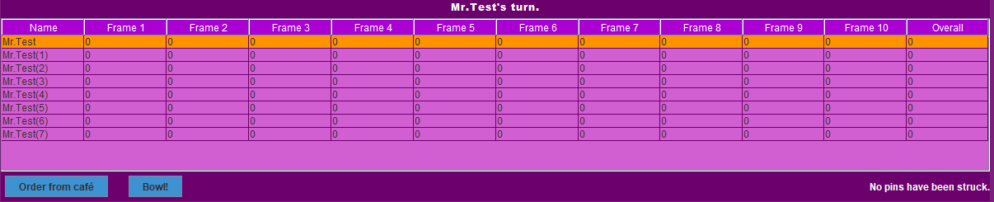

Figure

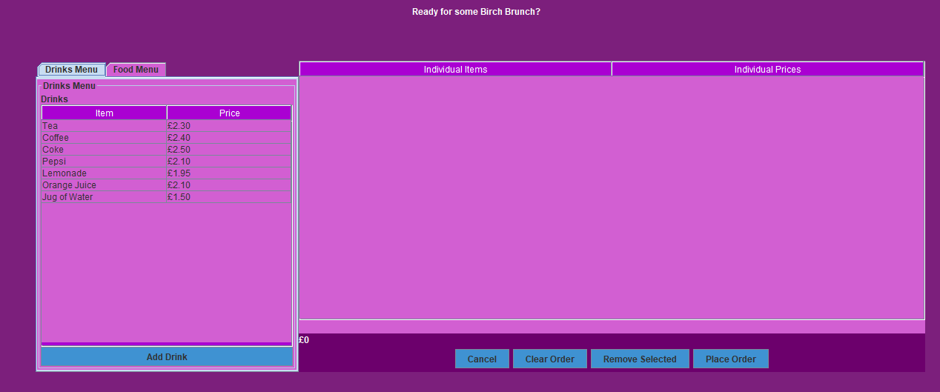

Figure

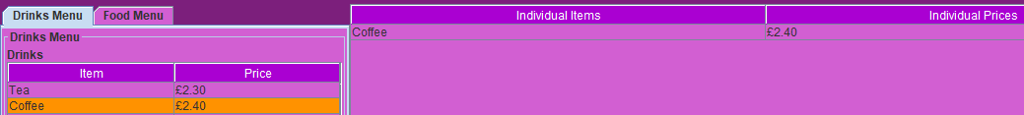

Figure

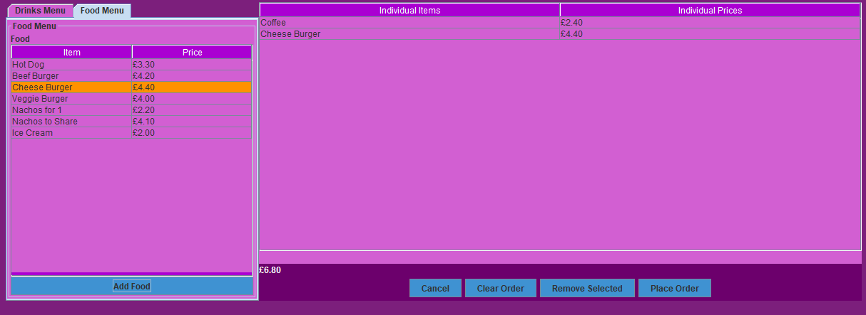

Figure

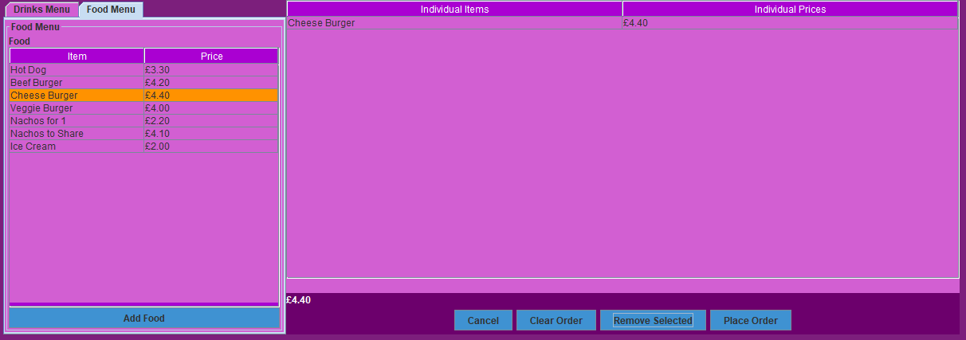

Figure

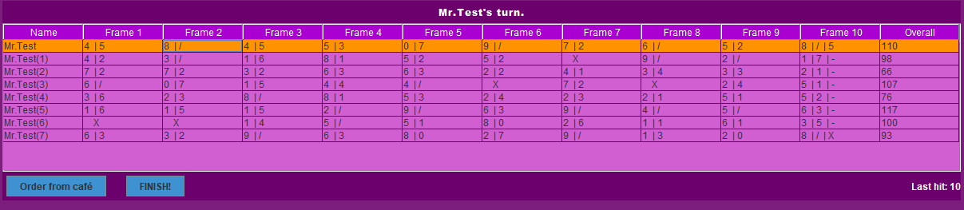

Figure

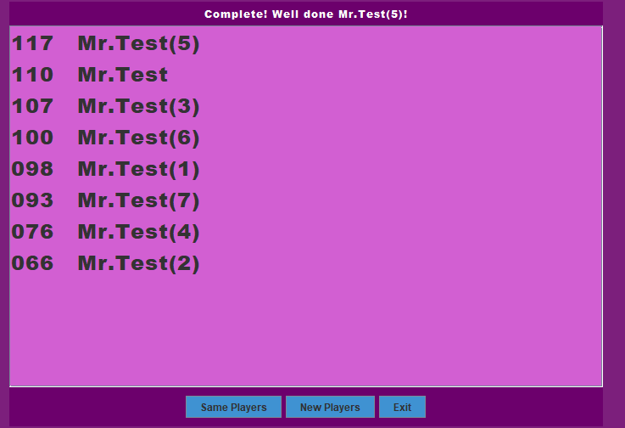

Figure

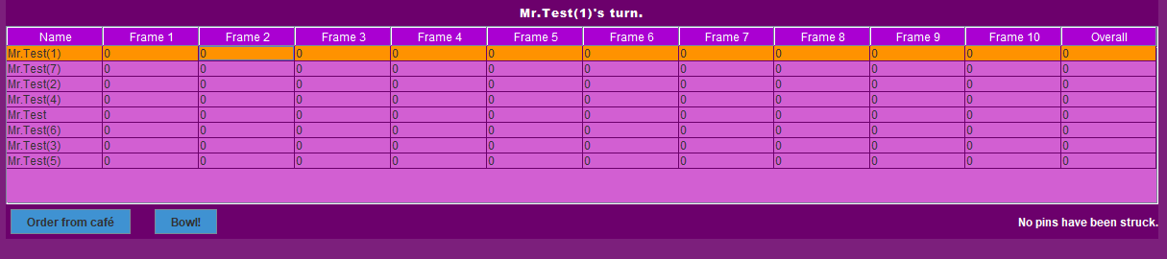

Figure

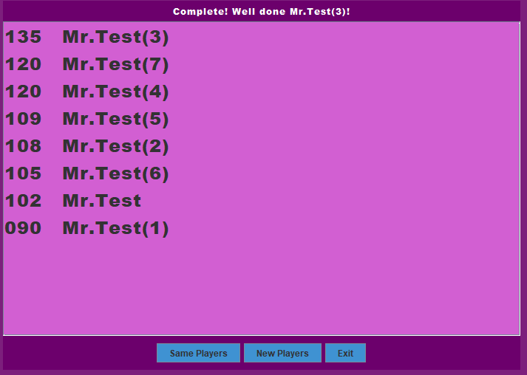

Figure

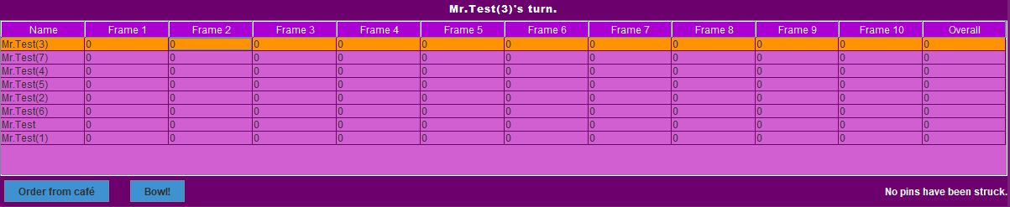

Figure